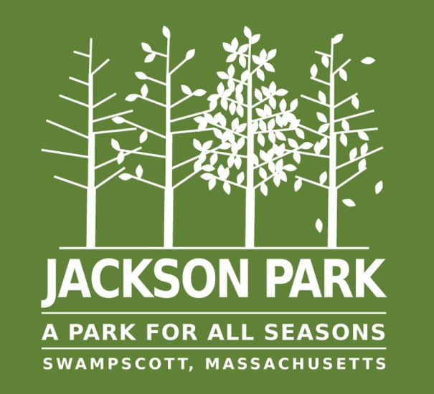

Free Metal Recycling

The Jackson Park Playground Committee will be holding monthly metal recycling events on the last Saturday of every month beginning in April through October 2015. The JP Committee is preparing for the grand opening of the playground this summer after seven years of planning and raising funds.  The metal collection has been extremely popular and is a win-win the environment and the residents with the added bonus of raising funds that support the playground project.

***Where:***

**Swampscott DPW Yard, 200 Paradise Road, Swampscott**

***When:***

* **Saturday, May 30 – (8:00a.m. to 12p.m.)**
* **Saturday, June 27 - (8:00a.m. to 12p.m.)**
* **Saturday, July 25 - (8:00a.m. to 12p.m.)**
* **Saturday, August 29 - (8:00a.m. to 12p.m.)**
* **Saturday, September 26 - (8:00a.m. to 12p.m.)**
* **Saturday, October 31 - (8:00a.m. to 12p.m.)**